Computer Communications and Networks (COMN)
2016/17, Semester 2

Assignment Part 2 Results Sheet
Forename and Surname: | Jianmeng Yu
Matriculation Number: | s1413557

Question 1 – Experimentation with Go-Back-N:
 | Throughput (Kilobytes per second)
Window Size | Delay = 5ms | Delay = 25ms | Delay = 100ms
1 | 45.80 | 9.83 | 2.37
2 | 84.25 | 18.79 | 4.71
4 | 75.47 | 34.67 | 9.14
8 | 126.05 | 68.46 | 17.56
16 | 175.34 | 116.74 | 34.87
32 | 157.56 | 109.54 | 65.55
64 | 141.33 | 102.97 | 112.50
128 | 132.62 | 73.91 | 126.78
256 | 62.48 | 75.83 | 108.31
Create a graph as shown below using the results from the above table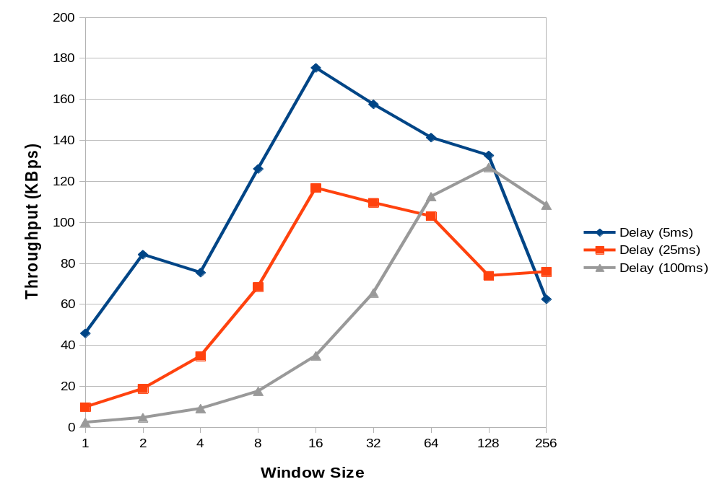

Question 2 – Discuss your results from Question 1.

The throughtput of data doubles with the window size for small window sizes, as the Sender utilize the wait time to send furthur packets, this is shown clearly in the 100ms case. When the window size keeps increase the sequence number may not catch up with the window, so it basically relys on the timeout to resend everything, resulting in the limit in speed, hence limiting the throughput around 100-150KBps. The transmitting speed start to lower after the limit, as there are too many packet to send, that first ACK of the resend ones arrives before resend finish, resulting in decrease in speed.

//Throughput varies depends on the time of the week/day. (Max reaches 600Kb/s at morning on weekends and maxout at 150Kb/s during noon on weekdays, and is very unstable)

Question 3 – Experimentation with Selective Repeat

 | Throughput (Kilobytes per second)
Window Size | Delay = 25ms
1 | 9.85
2 | 19.64
4 | 37.43
8 | 72.59
16 | 143.48
32 | 196.35

Question 4 - Compare the throughput obtained when using “Selective Repeat” with the corresponding results you got from the “Go Back N” experiment and explain the reasons behind any differences.

It's about 20% faster, and it breaches the “limit” using GBN. This is because not every single packet is resent after timeout, saving time for resending each of the not ACKed packets.

Question 5 – Experimentation with iperf

 | Throughput (Kilobytes per second)
Window Size (KB) | Delay = 25ms
1 | 14.24
2 | 22.18
4 | 44.80
8 | 71.68
16 | 84.53
32 | 186.67

Question 6 - Compare the throughput obtained when using “Selective Repeat” and “Go Back N” with the corresponding results you got from the iperf experiment and explain the reasons behind any differences.

The throughput is higher than my GBN and Selective Repeat at low window sizes, but it's slower than my selective repeat at higher window sizes. The time is probably spent on TCP handshaking and validating the packets, hence my Selective Repeat have a higher speed.

Used server side command:
iperf -s -p 54321 -w (1-32)KB
Used client side command:
iperf -c localhost -M 1KB -w (1-32)KB -p 54321 -F test.jpg -t 600

